ELEC 2520 Energy Systems and Control

LAB REPORT 1: Implementation of a DC-DC Converter Circuit with PWM Control
Student name | Student ID
Yingjie Luan | 200829024

Full marks will only be given if your calculations, derivation of formula and results have been explained clearly. Note that a high quality report which deserves a good mark is the one that has legible writing, well-sorted equations and well-presented diagrams. It is recommended that this report is typed out and diagrams are computer generated so that a more presentable report can be produced. NOTE THAT ALL DIAGRAMS TAKEN FROM OSCILLOSCOPE ARE NOT ACCEPTED IN THIS REPORT. GOOD QUALITY hand-written reports or reports with GOOD QUALITY hand-drawn diagrams are only acceptable and they MUST BE scanned and saved as one PDF copy/doc. file. The report must be submitted through VLE Turnitin by 11:59 pm Friday Week 7. The space provided below does not indicate the length of the report. If additional space is needed, feel free to use more pages. An electronic copy of this document is available at the VLE.

1 Hysteresis comparator
1.1 Draw a y-x plot of the comparator output voltage (V_{O} ) against the input voltage (V_{IN} ) showing clearly the calculated value of the comparator hysteresis when V_{REF} = 0, R₁ = 47kΩ and (i) R₂ = 47kΩ, (ii) R₂ = 4.7kΩ. (Use the scale 5V ~ 1cm for both plots.)

According to the natural characteristic of the Operational amplifier, we can conduct that:
V_{ref} = 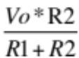
And because V_{pos} = V_{neg}, The two hysteresis value should be:
V_{ref}= 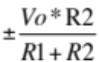, And Vo is the maximum output value which is 15V

When R2 = 47k, R1= 47k:
Vref = 7.5V.

In real experiment, the V_{o} is 14.7V, and we have:

 | V_{p} | V_{n}
Exp1 | 8.4V | -6.9V
Exp2 | 8.2V | -6.7V
Average Value | 8.3V | -6.8V

The plot:
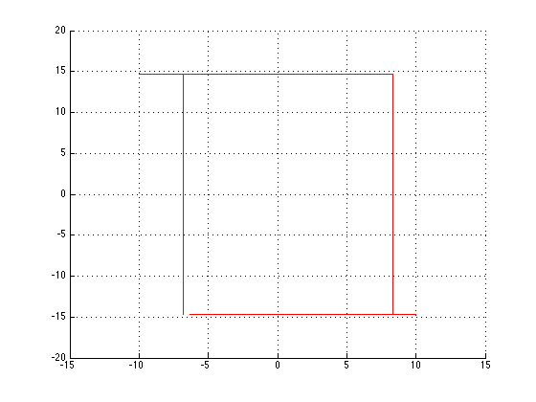

Similarly, when we change the R2 to 4K7, the Vo is still 14.7V.
Thus, The theoretical value is: 1.3636V

The experimental value:
 | V_{p} | V_{n}
Exp1 | 2.5V | -1.1V
Exp2 | 2.4V | -1.3V
Average Value | 2.45V | -1.2V

The plot:
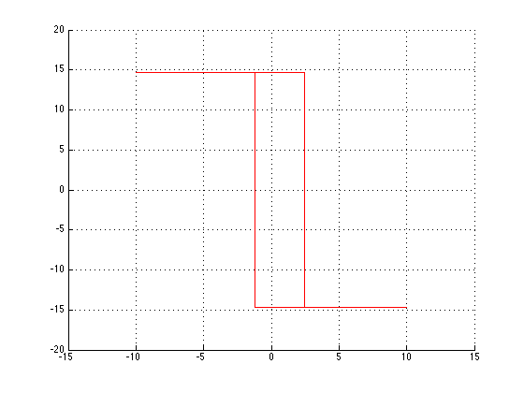

2 Free-running oscillator

2.1 Referring to the oscillator circuit of Fig 4, CLEARLY draw the theoretical waveforms of voltages V_{O}, V₁ and V_{C} together with the anticipated waveform of the capacitor current I_{C}.

V_{O:}
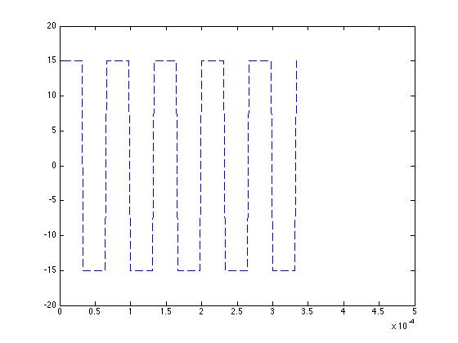

V_{C:}
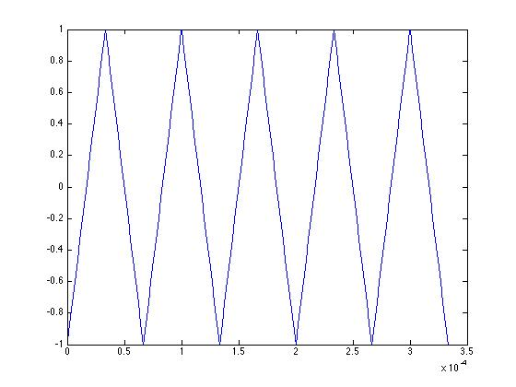

V_{1:}
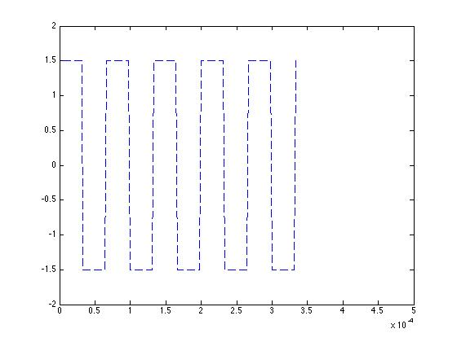

I_{C:}
Assuming the Vc as triangular waveform, because Ic = C*du/dt, The Ic keep constant as Vc increasing or decreasing.
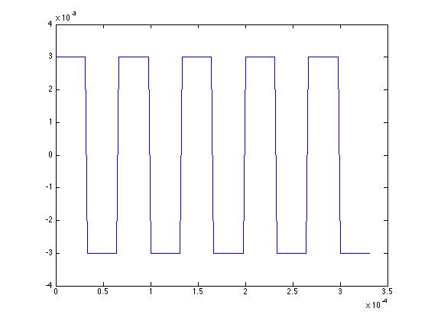

The Vc change from -1.5V to 1.5V over the time of 1/(15*10^3*2)S. So
abs(I) = 33nF *3V/(1/(15*10^3*2)s), which is 0.03A

2.2 Assuming that the voltage waveform V_{C} can be approximated by a triangular one, derive analytically the value of R_{F} at R_{V} = 0 and C=33nF to obtain a triangular waveform of frequency 15kHz and amplitude ± 1.5V.
(Include comments for your derivation.)

- To get Rf we must assume Vc as triangular waveform. And while we are doing so, we assume that :

Time constant/10 = Period/4: time constant = Rf*C
Deriving from this:
Rf = 2.5/(C*f):

Thus: Rf = 5.05KΩ

3 Square waveform with variable pulse width

3.1 Draw in a single diagram the ideal (theoretical) input (V_{IN}) and output (V_{O}) voltage waveforms of the comparator which produces the square waveform with 1:3 mark/space ratio. On the graph of V_{IN} indicate clearly the lines representing the reference (V_{REF}).
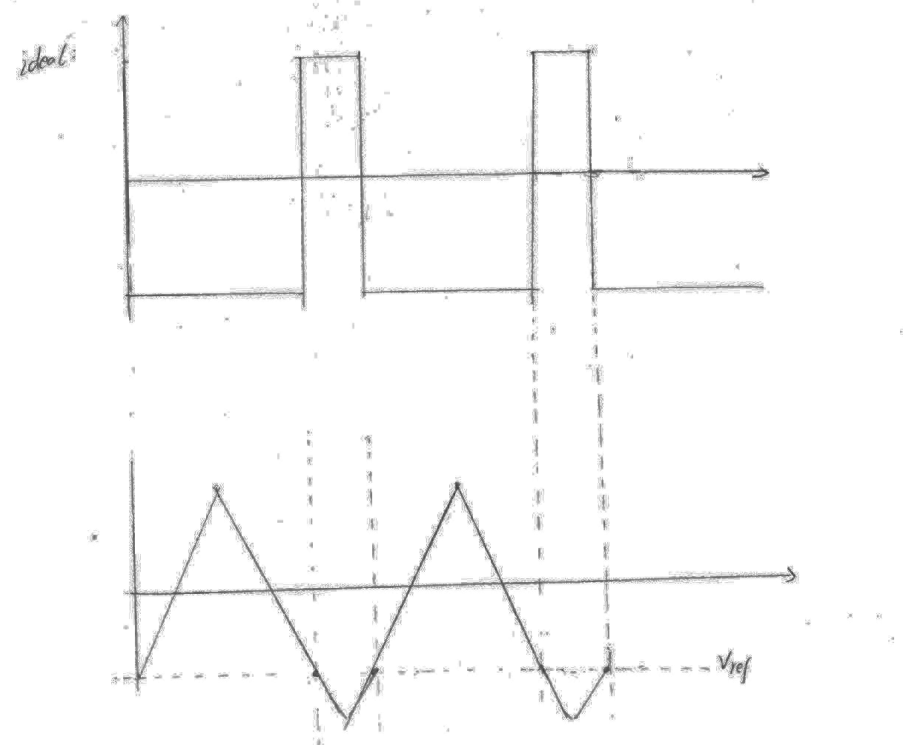

3.2 Draw in a single diagram the experimental input (V_{IN}) and output (V_{O}) voltage waveforms of the comparator which produces the square waveform with 1:3 mark/space ratio. On the graph of V_{IN} indicate clearly the lines representing the reference (V_{REF}) AND the hysteresis voltage (V_{H} ) and relate the intercept points with the output waveform. Explain any difference between the waveforms in 3.2 and those in 3.1.
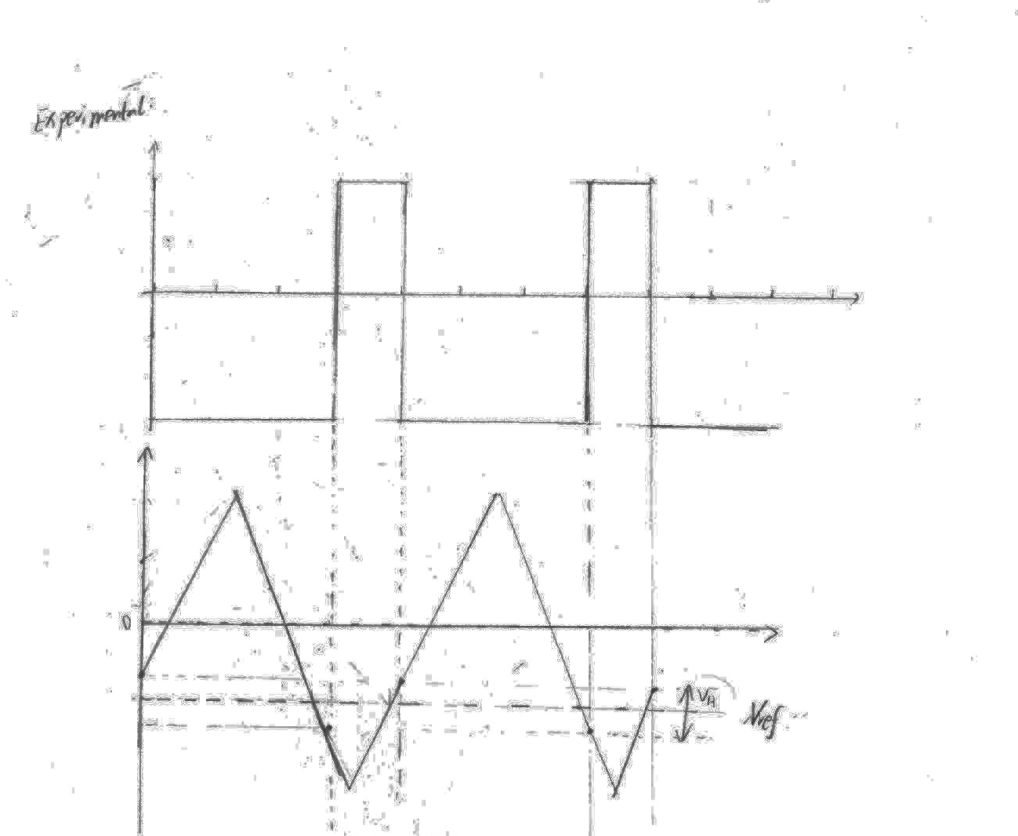

As we can see from the graph, that Vh does not equal to zero. That, practically, we can not get the ideal waveform where Vin larger than Vref is –Vo and Vin smaller than Vref is Vo. All in all, that is due to the physical characteristic of the hysteresis comparator.

3.3 Calculate the magnitude of the comparator hysteresis. What is the purpose of hysteresis in this case?

Using the formula from the handout, that:
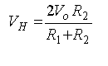
While we are given :
R2 = 10K, R1 = 1M and the Vo is the supplying voltage which is 15V.

Thus, Vh = 0.3V, which means there are two boundry located equally besides the Vref and the boundry width is 0.3V, which in turns also means that the two boundry values are Rref + 0.15V and Rref – 0.15V respectively.

The comparator hysterisis works like a filter, it convert the continus waveform into square wave form at the duty ratio of 0.5 and at the amplitude of Vo.( In fact, the input wave form is not required to be a triangular waveform, some others waveforms like sinosiode wave may also work)

4 MOSFET chopper with resistive load

4.1 Ignoring the voltage drop across the MOSFET switch derive an expression for average voltage (V_{AV}) across the lamp as a function of the supply voltage (V_{S} ) and the duty cycle (δ ). (Duty cycle is given as the `mark/[mark+space]' ratio, i.e. δ = t_{on} /T , where t_{on} denotes the time interval while the switch is in conduction, and T is the period of a chopping cycle.) Using the derived expression calculate the average voltage across the lamp when the mark/space ratio is 1:3 and V_{S} = 12 V.

Considering the Voltage drop across the inductor:

When switch is turned on:
L*di/dt = Vi – Vo
When switch is turned off:
L*di/dt = -Vo

Using finite time to approximate dt, thus we have the following:
L*di/(δ*Tp) = Vi – Vo and
L*di/((1-δ)*Tp) = -Vo
Because it is at steady state the rising and falling amplitude for di must be equal, thus we can conduct:

di(Switch on) = di(Switch off):

δ*Tp*(Vi–Vo)/L = (1–δ)*Tp*Vo/L

Simplifying the above equation we can get:

δ*Vi = Vo

According to the question: δ = 0.25 and Vs = Vi = 12V

Thus : Vo = 3V

4.2 Referring to the chopper circuit without inductor and the oscilloscope display when the supply voltage and the mark/space ratio are 12 V and 1:3 respectively, draw (a) the diagram showing the waveforms of currents through the lamp and the switch, and (b) the diagram showing the corresponding voltage waveforms. What would the average lamp voltage change if the mark/space ratio decreases/increases?

Waveforms of currents through the load and the switch:
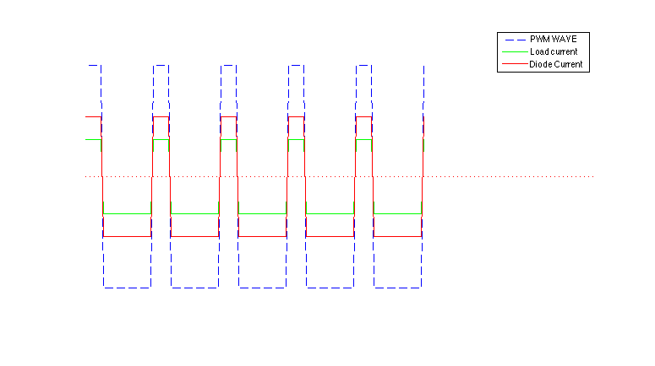

The voltage across switch and the load:

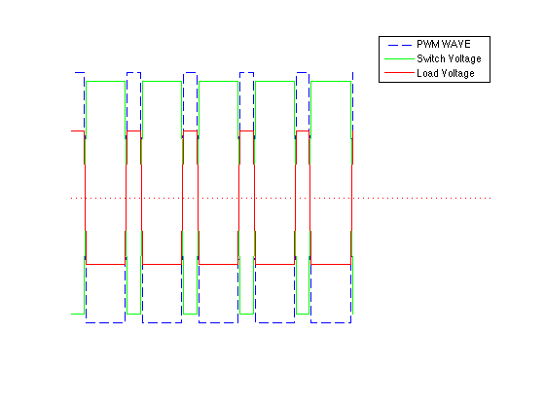

5 MOSFET chopper with filtering inductor
5.1 Referring to Figure 1 of the lab notes and the obtained oscilloscope waveforms, draw (a) a diagram showing the waveforms of currents through the lamp, the switch and the diode, and (b) a diagram showing the voltage waveforms across the lamp and the diode. (Consider 1:3 for mark/space ratio)

Currents through the load the switch and the diode:

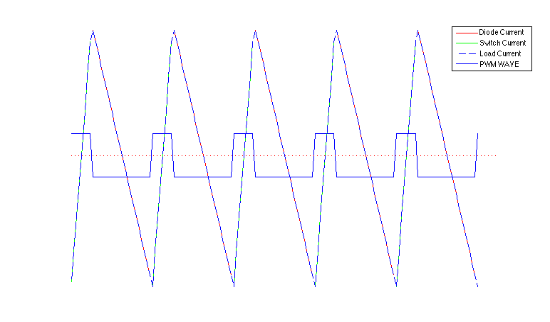

Voltage across diode and load:
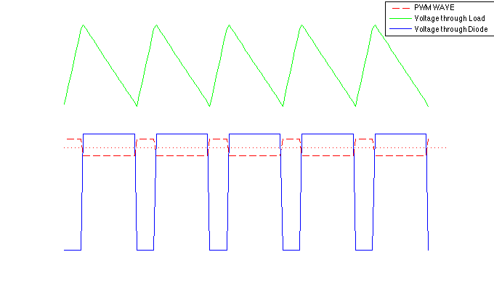

5.2 Specify (by giving names of devices) the power flow path during the time intervals when the MOSFET switch is in (a) ON state, and (b) OFF state. (Include your discussion)

When the switch is ON:

Because Vi is large that Vo, the current going from Vi to Vo, and first it goes through the MOSFET switch and then from the switch it runes into the inductor and then by Current and resistor.

At the main time, as we can see from the circuit that the voltage across the diode causing the diode reverse biased and there isn’t any current going through the diode.

When the switch is OFF:

When the switch is OFF, because of the switch is off, the input voltage cannot go from the Vin to Vo. And at the mean time, the inductor begin to discharge and the current goes from the inductor to the capacitor and load and by going though the diode the current goes back to the inductor. And as we can see, when the switch is off, the diode is forward biased and there is current going through the diode and voltage drop across the diode as well.

5.3 What is the average voltage across the inductor ? (Give a brief explanation.)

When the switch is on, we can get:
L * dI/dt = Vo – Vi
When the switch is off we can get:
L* dI/dt = -Vo
Where L*dI/dt is the voltage across the inductor, and because it is on for a period of K*Tp and it is off for a period of (1-K)*Tp. When can do a simple integration:

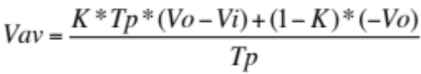

After calculation, the value of the above formula is 0. So the average voltage across the inductor is 0V.

5.4 How would the peak-to-peak lamp current compare in this case with that in the case when inductor is not used? You are not expected to work out the ripple magnitude. What is the purpose of the filtering inductor?

When inductor is used and peak-to-peak load current is smaller, that is because there cannot be any sudden change inside the inductor and that cause the changing ratio of the current become smaller.

The purpose of installing a filtering inductor is to smooth the output wave and to remove the harmonics inside the current, and by doing so we can get a purified and smoother wave.

